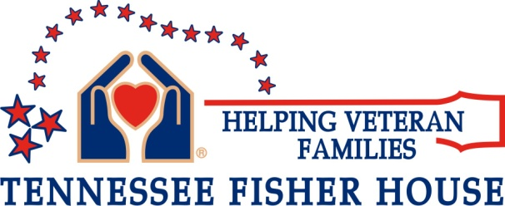

Wish List for the Tennessee Fisher House May, 2015

Below is a list of items to comfort our Veteran’s families and, in some way, ease their burdens.

Consumables: Toilet paper, Kleenex, paper towels, napkins, batteries (AA & AAA, C, D & 9volt), (HE fragrance free) laundry detergent preferably (Pods). Anti-bacterial wipes, paper “only” plates, bowels plastic/Styrofoam 16- 20oz cups, disposable coffee cups with lids, Clorox wipes, Lysol spray, & postage stamps.

Gift Cards:

Gift Cards larger amounts for household grocery purchases and smaller to give to guests. Local establishments nearby are Publix, Walmart, Kroger, Walgreens, McDonalds & Taco Bell.

Non-perishable Food and Snacks: Cereal bars, granola, individual packages of crackers & chips, and candy bars. Snack items should be things that are easy to take on the go to the hospital.

Drinks: Bottled water, soda, coffee & creamers.

Miscellaneous Items: Bath towels/ wash cloths & hand towels color white. Full size not hotel size, please. Shampoo only no conditioner, individually wrapped or small packets of makeup remover wipes, liquid shower gel no bar soap, please, hair combs/brushes, tooth brushes, tooth paste, women’s personal hygiene items.

Please note: We can only accept new items due to health concerns and standards.

To Coordinate Delivery please contact Fisher House Manager Becky Wood at 615-225-5758 or Email: Rebecca.Wood4@va.gov

We thank you on behalf of the grateful families who benefit from your generosity.

