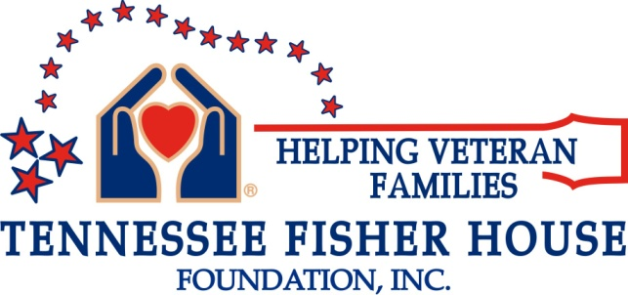

WISH LIST
Below is a list of items to comfort our Veteran’s families and, in some way, ease their burdens.
Consumables: (HE) laundry detergent. Anti-bacterial wipes, paper “only” plates, bowls, disposable coffee cups with lids, & postage stamps.
Non-perishable Snacks: Individual packaged chips, crackers, candy bars, granola bars.
Miscellaneous Items: Full-size (not hotel size please) shampoo only—no conditioner, individually wrapped or small packets of makeup remover wipes, liquid shower gel (no bar soap please), hair combs/brushes, toothbrushes, tooth paste, women’s personal hygiene items.
*Please note: We can only accept new items due to health concerns and standards.
To coordinate delivery, please contact Fisher House Manager Becky Wood at
615-225-5758 or email: Rebecca.Wood4@va.gov
Administrative hours are Monday to Friday 9:00 a.m. to 4:00 p.m.
We thank you on behalf of the grateful families who benefit from your generosity.

